# Name: Muhammad Ashir

Class: BSDS-3A

Roll No: 053

# Explanation:

This document explains to analyze the budgets of different movies and compare them with the average budget. The code helps to identify which movies have budgets that are higher than the average.

## Code Explanation:

1. First, I created a list called 'movies'. Each item in the list is a tuple that contains two parts: the movie name (string) and its budget (integer). This allows us to store data in a structured way.

2. I then created two variables: 'high_budget_movies' (an empty list to store movies that have budgets above the average) and 'total_budget' (set to 0 initially).

3. Next, I used a loop to go through each movie and add its budget to the total budget. This helps me calculate the overall budget of all movies combined.

4. Once the total budget was found, I divided it by the number of movies to calculate the 'average_budget'. This value represents the average money spent on a movie in this list.

5. After that, I used another loop to check each movie's budget. If a movie's budget was greater than the average, I added it to the 'high_budget_movies' list. I also calculated how much higher its budget was compared to the average (called 'over_average_cost').

6. For each movie above the average, the program prints the movie name, its budget, and how much more it cost than the average. Finally, it prints the total number of movies that had above-average budgets.

## Why This is Useful:

This program is useful because it teaches the basics of data analysis using Python. In AI and data science, it is very important to know how to process data, calculate averages, and find meaningful results. By working on this program, I practiced loops, lists, conditions, and calculations in Python.

It also shows how we can take real-world examples, such as movie budgets, and analyze them.

## Code:

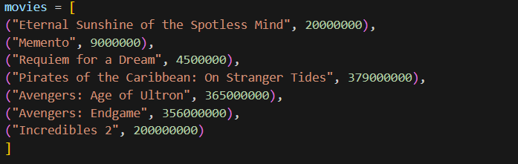

## Output:

